Lab 7: Capacitors and Capacitance

Phys 108L

Due March 30, 2020

# Preface

Welcome to Physics 108 Lab, Online! Just like the in-person lab, but modernized for the virtual future. These labs are written to be completed individually – if you answer all of the questions and do all the activities, it will be considered complete. However, feel free to collaborate with your friends and family.

We literally *just* entered the “cool part” of this lab (no offense to electrostatics, of course) where we play around with objects that are literally magic. We still want you to be able to witness the magic of physics with your own eyes, in the real world…and also get experience overcoming the realities of physical experiments and all the mess that comes with it. So these labs are designed to help *you*, dear student, enter a journey that puts you in a position to be touched by the beauty and magic of physics, while also being manageable in a situation far away from any Physics Lab™.

How, you ask? Well, that’s a question we’re all going to figure out … together :D So, we appreciate your patience as we put together the best way to get you the educational experience you worked hard for and deserve.

So, let’s start on the first lab: Capacitors and Capacitance!

# What is Capacitor?

Capacitors are one of my favorite circuit components. Their role is to accumulate and store charge.

Watch this video of a simple home experiment using a nine-volt battery, a capacitor, and an LED:

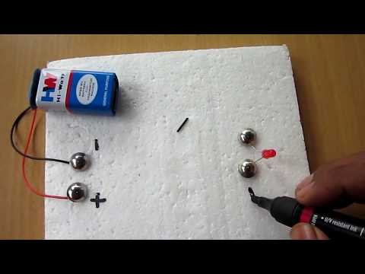

“Capacitor Charging and Discharging simple project”

<https://youtu.be/qqo7MTVksmo?t=180>

The relevant part is from 3:00 to 5:20 (from the beginning of the actual experiment to the triumphant thumbs up).

The same process is repeated many times, but is essentially:

1. The capacitor is charged using the battery, accumulating charge $Q=CV$.
2. The capacitor is connected to an LED: a circuit is completed and a charge flows between the ends of the capacitor connections, causing the LED to light up.

Literally magic, right?

Tell me about it. By answering these questions.

**QUESTION 1a**: This cylindrical capacitor is manufactured to have a capacitance of $C=450 μF$. The battery is $9 V$. After charging the capacitor in the way depicted in the video, how much charge stored on on the capacitor?

**QUESTION 1b**: Check out this article on ancient capacitors from the 1700’s: <https://en.wikipedia.org/wiki/Leyden_jar>. Do some research on how much the capacitance would typically be for a Leyden Jar of one pint. How much charge would such a jar accumulate if used like a capacitor in the same way?

**QUESTION 2**: Imagine you are an electron living in the negative terminal of the nine-volt battery, when one day you wake up to find yourself in the middle of the experiment in the video. Describe the journey you and your other electron friends take, from the beginning of the experiment to after the LED is finished lighting up. Explain your motivations during the journey, as well.

*Important*: Remember that charge is conserved: it never disappears. So, you aren’t going to die during this journey. You’re just going to move around a bit.

# Why is Capacitor?

Now that we know what a capacitor does, let’s imagine the physics behind specific capacitors. How would you make one, if you were stranded on a deserted island with only two sheets of conducting metal?[1]

One way is with a *parallel-plate capacitor*. This capacitor is simple enough that you can actually figure out its capacitance using Gauss’s law and $Q=CV$:

$$\begin{matrix}Q & =σA \\ E & =\frac{σ}{ε_{0}} \\ V & =Ed=\frac{σd}{ε_{0}} \\ C & =\frac{Q}{V}=σA\frac{ε_{0}}{σd} \\ & =\frac{ε_{0}A}{d}\end{matrix}$$

Neat. And we also know that in the presence of a dielectric with dielectric constant $κ$ (“kappa”), we have:

$$C=\frac{κε_{0}A}{d}$$

What does that look like in reality? To find out, watch this video:

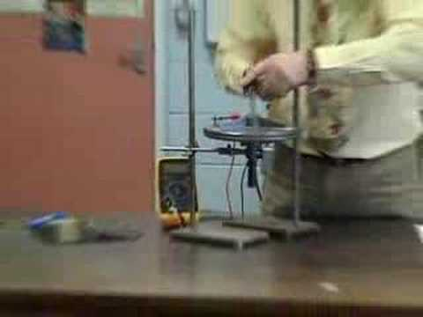

“Factors affecting a Parallel Plate Capacitor”

<https://youtu.be/jOBoDixh7lY>

Appreciate the man’s great taste in neckties. Then appreciate the parallel-plate capacitor. Then appreciate these questions.

**QUESTION 3**

Answer the following questions based on the multimeter readings at different points in the video. The multimeter is displaying the capacitance measurement in units of microfarads, $μF$.

1. Assume the plates are circular with a diameter of of $25. cm$. Looking at the multimeter reading at the start of it all (at timestamp 0m35s), what do you think the distance between the plates is?
2. After the physicist moves the top plate near to the edge (at timestamp 1m10s), what do you think the area of overlap between the two plates is, based on the multimeter reading?
3. After the physicist moves the top plate upwards all the way (at timestamp 1m45s), what do you think the distance between the two plates is, based on the multimeter reading? Assume the plates are still fully overlapping.
4. At timestamp 2m30s, the physicist sandwiches the two plates between dielectric material. Assume the dielectric material is $1.0 cm$ thick. Estimate the dielectric constant $κ$ of the dielectric material, based on the reading on the multimeter.
5. At timestamp 2m48s, he replaces the first dielectric material sheet with another sheet of the same thickness. Estimate the dielectric constant $κ$ of this new sheet based on the multimeter reading.

# How is Capacitor?

So now you know what to do you had to build a capacitor from scratch on a deserted island with only two plates of ideal conductors. However, this knowledge is admittedly a bit specialized. There are multiple ways to make capacitors (including the [Leyden Jar](https://en.wikipedia.org/wiki/Leyden_jar) mentioned before before). We mostly focus on parallel-plate capacitors because they are simple enough to easily deduce their capacitance based on their physical properties using Gauss’s Law.

In the big picture, we use many different capacitors without caring how they are actually *physically* made. We just need to know about their capacitance $C$, and we can think about how different configurations of capacitors give rise to different capacitances.

From [Kirchhoff’s Laws](https://en.wikipedia.org/wiki/Kirchhoff%27s_circuit_laws), we can actually derive how capacitors “combine”.

* If two capacitors with capacitance $C_{1}$ and $C_{2}$ are combined in **parallel**, they effectively act as a single capacitor with capacitance
$$C_{eff}=C_{1}+C_{2}$$

* If two capacitors with capacitance $C_{1}$ and $C_{2}$ are combined in **series**, they effectively act as a single capacitor with capacitance
$$\frac{1}{C_{eff}}=\frac{1}{C_{1}}+\frac{1}{C_{2}}$$

* You will often find that above relationship written as:

$$C_{eff}=\frac{C_{1}C_{2}}{C_{1}+C_{2}}$$

But…is this true? To investigate, let’s analyze this video:

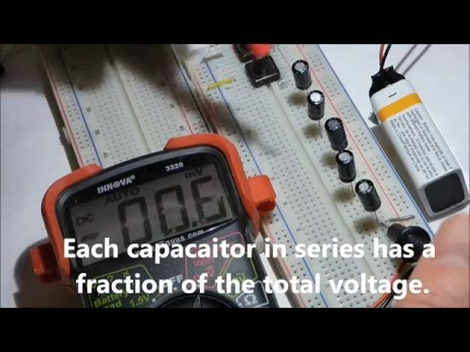

“Electronics. Series and parallel capacitor circuits explained and demonstrated without the math”

<https://youtu.be/mfvVXOAKgC4>

This video uses a breadboard (<https://en.wikipedia.org/wiki/Breadboard>), which is a really nice way to build custom circuits at home.[2] The actual experiment is essentially the same as the first video, except a littler smoother to switch out for different capacitors. The first button charges the capacitors, and the second button connects the capacitors over the LED to discharge.

The neat thing happening here is we can see that the duration the LED is on (the “discharge time”) is affected by the capacitance. We will learn exactly *why* and *how* later on when we talk about RC circuits, but for now let’s assume that the discharge time is proportional to the capacitance. We’re going to use this to *prove* the parallel/series effective capacitance relationships.

**ACTIVITY**

Open up this spreadsheet and make a copy of it (File -> Make a copy) so you can edit it on your own:

<https://docs.google.com/spreadsheets/d/1kKads5CD_dU5zt7aT710Q1EWwoWUe9jJheguK03ywu0/edit?usp=sharing>

1. From timestamps 0m27s to 1m42s, the experimenter tests out the LED discharge time for different numbers of capacitors chained in parallel.

* In the spreadsheet, on the first page Parallel, under the column Eff. Capacitance (μF), compute the effective capacitance (in microfarads) for each number of capacitors, using . Remember that the capacitance of the single capacitor was $47 μF$
* Then, under the column Discharge Time (s), watch the video closely and, with a stopwatch (like on a smartphone app, or a stopwatch online) measure the discharge time for each test. Be sure to measure the time from when the light starts flashing to when the LED becomes completely dim again.
* As you do this, the plot will begin to fill up with your data. *If* the “parallel capacitors relationship” you used is true, then the plot should yield a linear relationship as expected.
* Copy the plot image with all *six* data points (Ctrl+C) and paste it into your lab report.
* Look at the plot. Is it linear? Is it effective in showing that the $C_{eff}=C_{1}+C_{2}$ law is true?

1. From timestamps 2m20s to 3m48s, the experimenter tests out the LED discharge time for different numbers of capacitors chained in series.

* In the spreadsheet, change the sheet to Series (on the bottom left corner of the page) to see a fresh new data table. Under the column Eff. Capacitance (μF), compute the effective capacitance (in microfarads) for each number of capacitors, using . Remember that the capacitance of the single capacitor was $47 μF$.
* Then, under the column Discharge Time (s), watch the video closely and measure the discharge times for each test in the same manner that you did before. Note that this is a different circuit than before, so remember to re-measure the time for the 1 capacitor circuit, as well.
* As you do this, the plot will begin to fill up with your data. *If* the “series capacitors relationship” you used is true, then the plot should yield a linear relationship as expected.
* Copy the plot image with all *five* data points (Ctrl+C) and paste it into your lab report.
* Look at the plot. Is it linear? Is it effective in showing that the $C_{eff}=\frac{C_{1}C_{2}}{C_{1}+C_{2}}$ law is true?

1. Explain the potential sources of error in your plots.

# Conclusion

Hopefully by the end of this lab exercise, you have gained an appreciation for the magic of capacitors. It’s really easy to just think of all this electric field stuff as only existing in an abstract microscopic world. However, capacitors are one way that all of this actually becomes very *real* at macroscopic scales that you can see and touch with your own eyes. All of this stuff we did with E-fields and Gauss’s Law and voltage … it’s true. All of it.



Han Solo attests to the truth of electrostatic theory

**REFLECTION**

You’ve witnessed what capacitors can do when put in the right circumstances. Can you imagine a situation where a capacitor (and being able to store and release charge) might help *you*, directly, in your everyday life?

# Manifest

Before you turn in your lab report, make sure it it includes (as a Word document):

* Your name and section
* Question 1a, 1b
* Question 2
* Question 3a, 3b, 3c, 3d
* Activity questions
* Activity plots pasted in
* Reflection

1. Good thing you had the foresight to pack those ideal capacitor sheets.
2. Just seeing a breadboard brings back a lot of nostalgia for me…late nights in physics lab, collectively suffering together with all my classmates. Sometimes we’d get bored and make random circuit projects just for fun…I remember hooking up a few buttons and making a little musical keyboard. I didn’t get any points for it but helped those sleep-deprived nights just a little bit more homely.